# Vehicle Tracking System

Mr Singh owns a local car garage and wants to keep track of vehicles that he has sold. He hired a local software development company to develop a new system for him, but they didn’t deliver the software on budget.

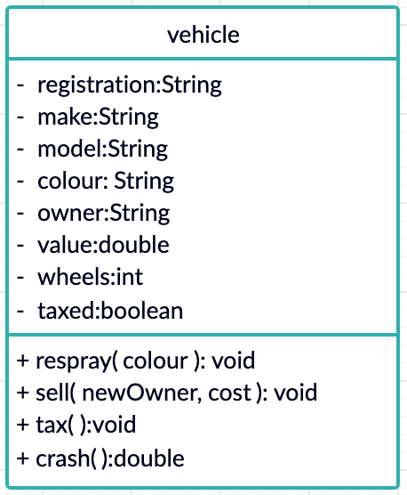The company has provided their UML diagrams and Mr Singh wants you to develop the system for him.

## Task 1

Create the vehicle class based on the class diagram provided.

The methods are described below.

### Respray

This method should update the colour instance variable with the value provided in the method argument.

There is no return from this method.

### Sell

This method should update the owner and value instances variables with the values provided in the method arguments.

There is no return from this method.

### Tax

This method should set the taxed Boolean variable to TRUE and reduce the value of the car by 5%.

There is no return from this method.

### Crash

The crash method should reduce the value of the vehicle by 50% and set the taxed variable to FALSE.

This method should return the new value of the car.

## Task 2

Create suitable Accessor methods for the following variables

* Registration
* Make
* Model
* Owner
* Value

## Task 3

Mr Singh has decided to start selling motorbikes as well as cars. He’s been advised that *sub-classes*would be suitable.

Design 2 sub-classes, bike and car, which extend the vehicle class.

The car class should:

* Set the wheels instance variable to 4

It should add the following additional instance variables:

* Doors – Integer
* Seats – Integer
* Sunroof – Boolean

The bike class should:

* Set the wheels instance variable to 2
* Override the crash method – reducing the value of the vehicle by 75% instead of 50%.

## Task 4

Finally, create a class called garage. The class should have an array of cars, and an array of bikes.

Mr Singh would like the option to print out the information on all of the vehicles he has sold with 1 click.

Implement this in the garage class.